**The value of artificial intelligence in the detection of early cerebral changes in acute stroke using non-contrast CT scans**

**Abstract**

**Background:** Over the last few years, there has been increasing interest in the use of deep learning algorithms to assist with abnormality detection on medical images. **Aim and Objective:** was to assess the value of artificial intelligence in the detection of early cerebral changes in acute stroke using non-contrast CT scans. **Patient & Methods**: this cross sectional study included 1095 patients distributed across both training and validation, as well as a separate test set. Using 48 hours follow up non contrast CT images as the main reference standard to diagnose the acute ischemic stroke at the initial CT images & AI. Axial scanning extending from base of the skull up to the vertex with coronal & sagittal reformate images**. Results:** There were no statistically significant differences found among the diagnosis results of the first and second radiologist’s diagnosis and the AI system diagnosis (p > 0.05). **Conclusion:** In spite CAD system has established fair accuracy, the need of more accurate algorithm is necessary to determine if it can replicate non contrast CT and radiologist observations.

**Keywords:** Artificial Intelligence; non contrast computed tomography scan; acute ischemic stroke.

**Introduction**

Management of stroke highly depends on information from imaging studies. Non-contrast computed tomography (CT) and magnetic resonance imaging (MRI) can both be used to distinguish between ischemic and hemorrhagic stroke, which is difficult based on clinical features. Stroke imaging also gives insight into prognosis. One important caveat about stroke imaging is that it must be done quickly, as faster treatment leads to better outcomes. **(1)**

However, most steps in the stroke imaging triage pathway require the presence of human radiologists and neurologists, and this is often the time-limiting step. The expertise required for these tasks may not be available at all sites or at all times. Therefore, there is interest in automated methods for stroke imaging evaluation **(2)**

Stroke may be a suitable application for precision medicine and Artificial intelligence (AI) techniques because of the vast amount of data and multidisciplinary approaches used in making clinical decisions. In particular, brain imaging, which is the key factor in stroke management and forms the basis for numerous complexes go/no-go decisions, is an attractive subject for AI techniques **(3)**

AI is a broad term that describes any task performed by a computer that normally requires human intelligence. Machine learning (ML), which falls under the umbrella of AI, is a branch of data science that enables computers to learn from existing “training” data without explicit programming to make predictions about new data points **(4)**

Deep learning (DL) is a more recently developed technique of machine learning, which mimics the human brain using multiple layers of artificial neural network (ANN). Although there are no explicit criteria on the threshold of depth to discriminate between shallow and deep learning, the latter is conventionally defined as having multiple hidden layers **(5)**

AI techniques in stroke imaging could markedly change the milieu of stroke diagnosis and management in the near future. Automated diagnosis of stroke may be popular in an era where fast thrombolysis, and even prehospital thrombolysis, is recommended **(6)**

This study aimed to assess the value of artificial intelligence in the detection of early cerebral changes in acute stroke using non-contrast CT scans

**Patients and methods**

This is a cross-sectional study, occurred at Radiology Department of Benha university hospital between January 2023 till September 2024. It included 1095 patients, were collected from two main sources (radiology department at Benha University & Kaggle datasets), distributed across both training and validation, as well as a separate test set. 895 cases used for model training and validation distributed as 500 (45.66%) normal cases and 395 ischemic (36.07%), 200 (18.26%) cases who were referred to the department with stroke used for model testing.

Cases were selected randomly based on inclusion criteria from patients with clinical manifestations of acute cerebral stroke & imaged with non-contrast CT scan. There was no age or gender preference, the patients’ age ranged from 21 to 73 years, 132 patients were females (66%) and 68 were males (34%). The study was approved by the ethical committee of the Benha university hospital. A written consent and thorough medical history were taken.

**Inclusion criteria:**

Patients with clinical suspicion of acute cerebral stroke who underwent non-contrast CT scan then the CT DICOM images were interpreted by two radiology consultant’s with10 & 15-years’s experience then processed by AI model.

**Exclusion criteria**

Patients diagnosed with haemorrhagic stroke at the initial CT scan, Patients with clinical suspicion of acute cerebral stroke with normal follow up non contrast CT scan findings, CT scans not assessed by the AI.

Automatic detection of early cerebral ischemic changes based on non-contrast CT brain scans using the artificial intelligence technology applied in non-contrast CT DICOM images to detect the presence of these early ischemic changes, including hyper dense vessel sign, loss of grey-white matter differentiation, hypo-attenuation of deep nuclei, gyral effacement & insular ribbon sign.

All CT examinations were performed using a third-generation dual-energy CT scanner (GE 128 slice CT scan machine), we used the following parameters during CT scanning:

* KV in the range of 80–100kv.
* The gantry speed is set at a 0.35 s rotation.
* Helical thickness of 0.2–0.4 mm.
* Prospective gating.

The preprocessing code analyzes each case folder and extracts the top 10 largest contours based on their area. These contours represent the most significant regions within the brain scans, the objective of the preprocessing code is to extract and isolate the brain region from DICOM images, The code applies various image processing techniques, including transforming the images to Hounsfield Units, windowing, contour extraction, rotation, resizing, and cropping.

After collecting data we started to build our deep-learning model which based on convolutional neural networks (CNN).

**Approval Code : MD 14-8-2022**

**Statistical analysis**

The statistical analysis was conducted using the Software, Statistical Package for Social Science, (SPSS Inc. Released 2009- PASW Statistics for Windows Chicago: SPSS Inc.) The collected data were summarized in terms of mean ± Standard Deviation (SD) and range (minimum - maximum) for quantitative data and frequency and percentage for qualitative data. The collected data were analyzed using suitable statistical methods. Statistical significance was accepted at P value <0.05. A P value <0.001 was considered highly significant while a P value >0.05 was considered non-significant

**Results**

A total of 1095 cases were included in this study, consisting of 500 normal cases and 395 ischemic cases used for training and validation, and 200 cases reserved for testing. The AI model achieved notable success in accurately identifying early ischemic strokes, particularly in challenging regions like the brain stem and cerebellum, which are traditionally difficult to diagnose with CT imaging.

The model’s accuracy in detecting ischemic cases was 86 % during testing. It demonstrated strong performance in filtering out irrelevant slices, such as those containing bone structures or affected by motion artifacts. By focusing on the top ten selected slices per case, the model improved detection precision, leading to fewer false positives and false negatives.

The mean age of patients was 45.7 ± 11 years and 132 patients (66.0 %) were females and 68 patients (34.0 %) were males **Table (1)**

**Figure (1**) demonstrate that the most common risk factor was hypertension (n=57, 57.0%) followed by diabetes mellitus and dyslipidemia (n=48, 48.0% for each).

The time between stroke and presentation to radiology department ranged from 1.5 to 27 hours, with a mean of 9.09 ± 6.21hours. **Table (2)**

Both radiologists diagnosed 86 patients (43.0%) as having ischemic insult and 114 patients (57.0%) as being normal .**table (3**)

The AI system diagnosed 118 patients (59.0%) as having ischemic insult and 82 patients (41.0%) as being normal. **Figure** (**2)**

The final diagnosis of the studied patients. Ischemic lesions were shown in 114patients (57.0%) and the remaining 86 patients were normal (43.0%). **Table (4)**

The ROC curve analysis to assess the validity of radiologists and AI system diagnosis to discriminate ischemic lesions. For the first and second radiologists’ diagnoses, the AUC was 0.834, the sensitivity was 72%, the specificity was 94.74%, the PPV was 94.74%, and the NPV was 72% (p < 0.001, for each). Regarding the AI system diagnosis, the AUC was 0.788, the sensitivity was 84%, the specificity was 73.68%, the PPV was 80.77%, and the NPV was 77.78% (p < 0.001). **Table (5)**

**Case presentation (1): male patient, 61 years old hypertensive, presented with dysarthria and right sided hemiparesis. Figure (3)**

**Case presentation (2): Female patient, 60 years old hypertensive, presented with sudden loss of consciousness. Figure (4)**

**Discussion**

The Artificial Intelligence has been witnessing monumental growth in bridging the gap between the capabilities of humans and machines. Importantly, 40 to 60% faster scanning is available due to artificial intelligence in scanners. The only signal is properly selected for image reconstruction while noise is carefully suppressed. Motion artifacts are also suppressed in non-cooperative stroke patients **(7)**.

In comparison to visual inspection by human experts, the AI models may offer a number of advantages, including speed, large-scale deployment, objective and quantitative evaluation, and the ability to spot minute voxel-level patterns. **(8).**

Through our study we have attempted to assess the efficacy of the AI model in detection of the early cerebral changes of the acute ischemic stroke based on the non-contrast CT images that were performed for patients presented clinically with acute stroke. the patients’ age ranged from 21 to 73 years, 132 patients were females (66%) and 68 were males (34%)., There was a no statistically significant differences were found among the diagnosis results of the first and second radiologists diagnosis and the AI system diagnosis (p > 0.05).

The use of Python as the programming language and the development of a desktop application software using a deep-learning model demonstrate the potential of this study in detecting brain stroke from CT images.

Several previous studies have focused on using AI models for stroke detection, but there are notable differences between their approaches and ours. For instance, (Barros, et al), developed a model that primarily focused on large vessel occlusions, while our model was trained to detect early ischemic changes in a broader range of cases, including smaller strokes.**(9).**

Another study by Tasci used MRI imaging as their primary diagnostic tool, which offers higher resolution for soft tissue but is less accessible and more time –consuming than CT. in contrast, our work centers on CT scans , which are widely available and often first-line imaging modality in emergency stroke diagnosis**(10)**

**Conclusion**

Our study concluded that the AI model demonstrated significant potential in enhancing the early detection of ischemic strokes using CT imaging.by focusing on critical areas such as the brain stem & cerebellum, and employing advanced image processing techniques to exclude irrelevant slices, the model improved diagnostic accuracy. These findings suggest that AI can play a crucial role in supporting radiologists reducing diagnostic time, and improving patient outcomes, particularly in emergency settings.

**Author contribution**

Authors contributed equally in the study.

**References**

1. Saver JL. Time is brain–quantified. Stroke. 2006; 37:263–266.2.
2. [Kim M](https://www.ahajournals.org/doi/full/10.1161/STROKEAHA.119.027479) ,[Patrick T](https://www.ahajournals.org/doi/full/10.1161/STROKEAHA.119.027479), [Greg Z](https://www.ahajournals.org/doi/full/10.1161/STROKEAHA.119.027479). Artificial Intelligence Applications in Stroke. Stroke. 2020; 51:2573–2579.
3. Hinman JD, Rost NS, Leung TW, Montaner J, Muir KW, Brown S, et al. Principles of precision medicine in stroke. J Neurol Neurosurg Psychiatry. 2017; 88:54–61.
4. Chartrand, G., Cheng, P.M., Vorontsov, E., Drozdzal, M., Turcotte, S., Pal, C.J., et al. Deep learning: a primer for radiologists. Radiographic 2017; 37(7):2113–2131.5.
5. Eun-J, Yong-Hwan K,a, Namkug K and Dong-Wha K . Deep into the Brain: Artificial Intelligence in Stroke Imaging. J Stroke. 2017 Sep; 19(3): 277–285.
6. Weber JE, Ebinger M, Rozanski M, Waldschmidt C, Wendt M, and Winter B, et al. Prehospital thrombolysis in acute stroke: results of the PHANTOM-S pilot study. Neurology. 2013; 80:163–168.
7. Zeleňák, K., Krajina, A., Meyer, L., Fiehler, J., Behme, D., Bulja, D., et al. How to Improve the Management of Acute Ischemic Stroke by Modern Technologies, Artificial Intelligence, and New Treatment Methods. Life, (2021). 11(6), p.488.
8. Pacchiano, F., Tortora, M., Criscuolo, S., Jaber, K., Acierno, P., De Simone, M., et al. Artificial intelligence applied in acute ischemic stroke: from child to elderly. La Radiologia Medica, (2024), 129(1), pp.83–92.
9. Sales Barros, R., Tolhuisen, M.L., Boers, A.M., Jansen, I., Ponomareva, E., Dippel, D.W.J., et al. Automatic segmentation of cerebral infarcts in follow-up computed tomography images with convolutional neural networks. Journal of Neuro Interventional Surgery (2019), 12(9), pp.848–852.
10. Tasci, B. Automated ischemic acute infarction detection using pre-trained CNN models’ deep features. Biomedical Signal Processing and Control, (2023). 82, p.104603.

**Table (1) Distribution of the studied cases according to demographic data**

|  |  |  |
| --- | --- | --- |
| Demographic data |  |  |
| Age (years) | | |
| Min. – Max. | 21 – 73 | |
| Mean ± SD. | 45.7 ± 11 | |
| Median (IQR) | 48 (39 – 52) | |
| Sex: n (%) | | |
| Female | 132 | 66.0% |
| Male | 68 | 34.0% |

**Table (2):** Distribution of the studied cases according to clinical data

|  |  |  |
| --- | --- | --- |
| Demographic data |  |  |
| Time to presentation (hours) | | |
| Min. – Max. | 1.5 – 27 | |
| Mean ± SD. | 9.09 ± 6.21 | |
| Median (IQR) | 7 (4 – 7) | |

**Table (3) CT diagnosis of the studied patients**

|  |  |  |
| --- | --- | --- |
| CT diagnosis |  |  |
| First radiologist diagnosis: n (%) | | |
| Normal | 114 | 57.0% |
| Ischemic | 86 | 43.0% |
| Second radiologist diagnosis: n (%) | | |
| Normal | 114 | 57.0% |
| Ischemic | 86 | 43.0% |

**Table (4)** : the final diagnosis of the studied patients

|  |  |  |
| --- | --- | --- |
| Final diagnosis |  |  |
| Final diagnosis: n (%) | | |
| Normal | 86 | 43.0% |
| Ischemic | 114 | 57.0% |
| Number of lesions: n (%) | | |
| Single | 72 | 83.7% |
| Multiple | 14 | 16.3% |
| Site of lesions: n (%) | | |
| Right | 38 | 44.2% |
| Left | 44 | 51.2% |
| Bilateral | 4 | 4.6 % |
| Size of lesions: n (%) | | |
| Small (<5 cm) | 30 | 34.9% |
| Large (≥ 5 cm) | 56 | 65.1% |

**Table (5):** Validity of radiologists and AI system diagnosis to discriminate ischemic lesions

|  |  |  |  |
| --- | --- | --- | --- |
|  | First radiologist | Second radiologist | AI system |
| AUC | ‎0.834 | ‎0.834 | 0.788 |
| P | < 0.001* | < 0.001* | < 0.001* |
| Sensitivity | 72% | 72% | 84% |
| Specificity | 94.74% | 94.74% | 73.68% |
| PPV | 94.74% | 94.74% | 80.77% |
| NPV | 72% | 72% | 77.78% |

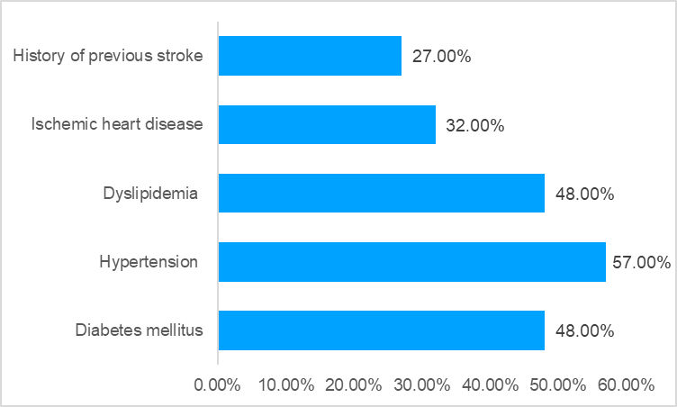

**Figure (1): Distribution of the studied cases according to risk factors.**

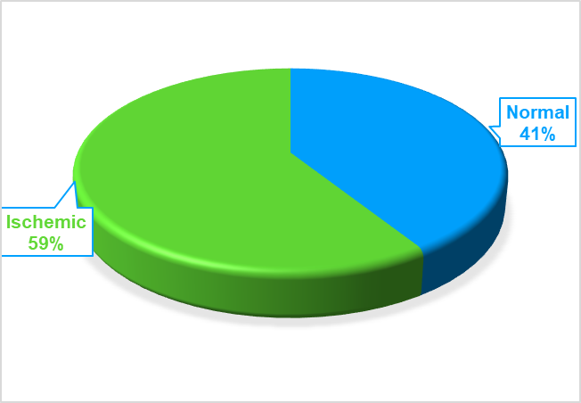

**Figure (2): The AI system diagnosis of the studied patients.**

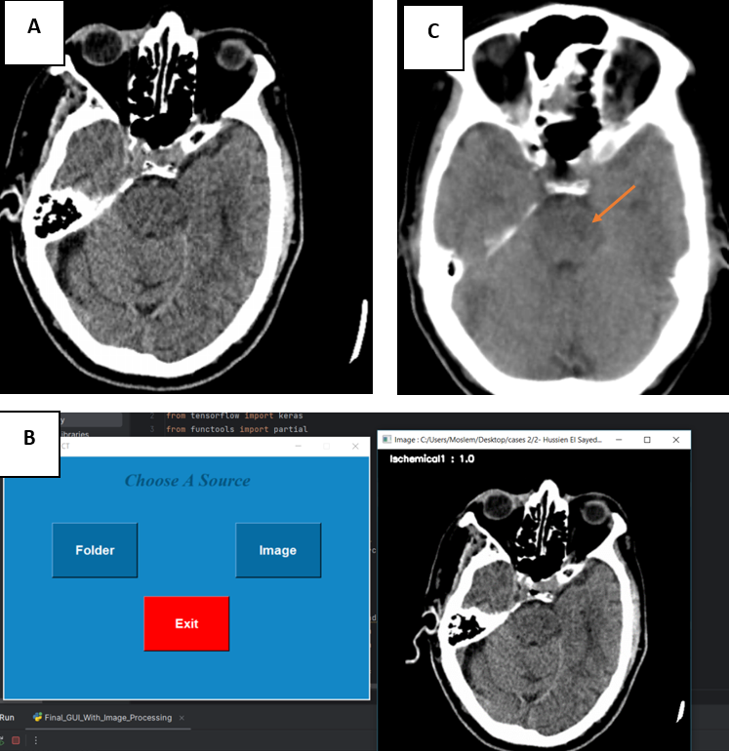

**Figure 3: Case presentation,** male patient, 61 years old hypertensive, presented with dysarthria and right sided hemiparesis, non-contrast CT scan of the brain axial cuts at the time of admission (A) reported as no evidence of ischemic changes, post processed AI image (B) marked the level of the brain stem (upper pontine) as ischemic, post 48 hours follow up image (C) revealed, left pontine hypo dense patchy area matching with acute / early subacute infarction (orange arrow).

**Figure 4: Case presentation**: Female patient, 60 years old hypertensive, presented with sudden loss of consciousness.non contrast CT scan of the brain axial cuts at the time of admission (A) revealed suspected left lentiform nucleus obscuration mostly secondary to cytotoxic edema, post processed AI image (B) marked the level of the basal ganglion as ischemic, post 48 hours follow up image (C) revealed, left basal ganglion (particularly head of caudate and lentiform nucleus) ill-defined hypo dense areas matching with acute / early subacute infarction (blue arrow).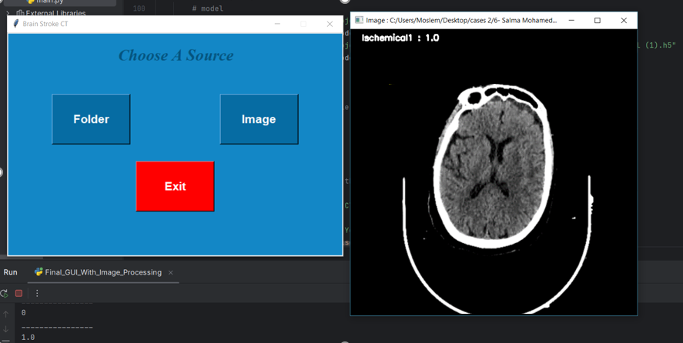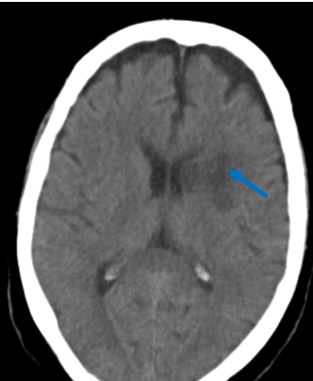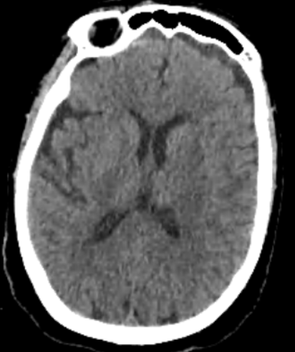

**C**

**B**

**A**